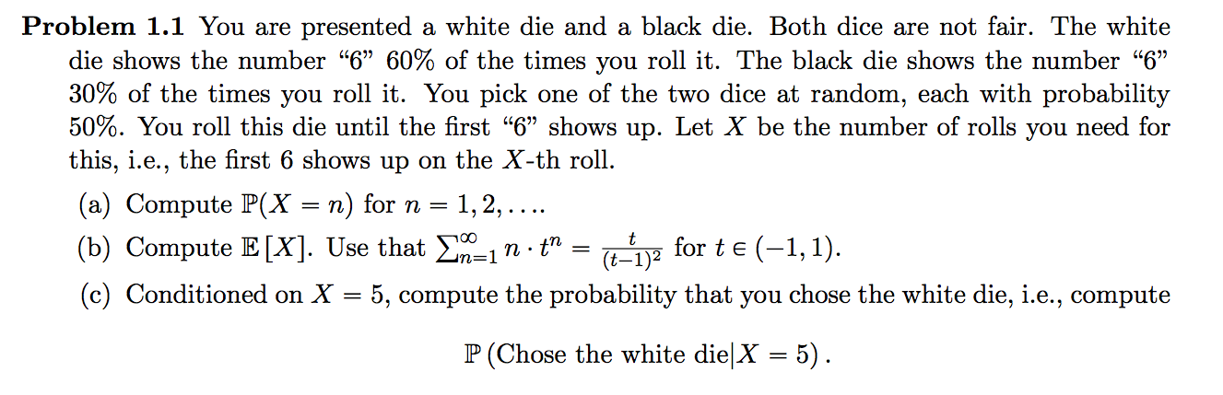



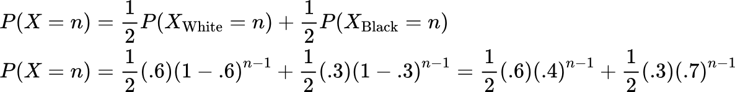



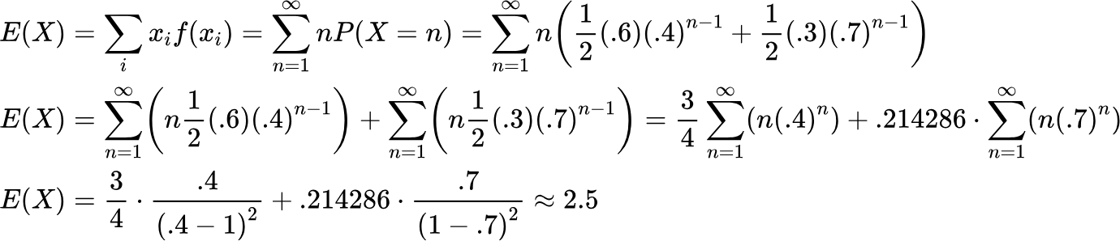



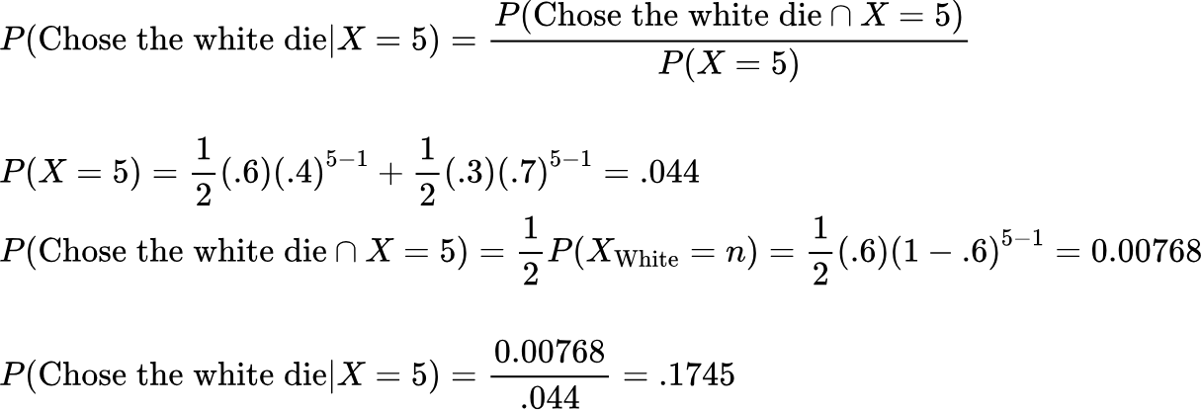

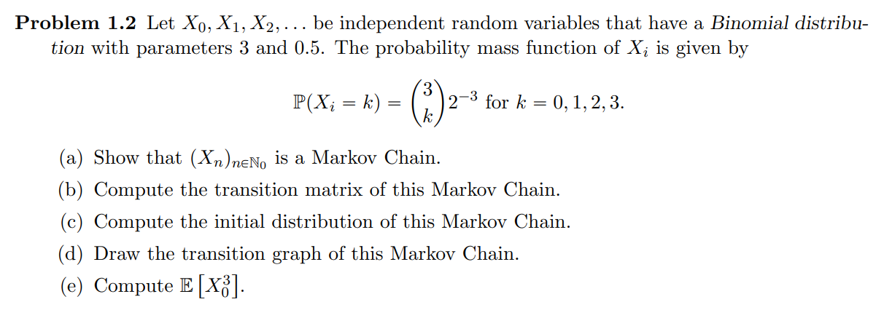

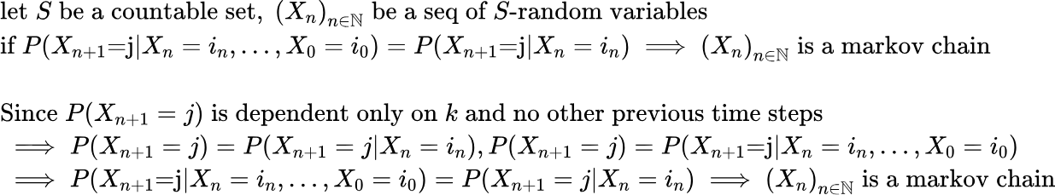



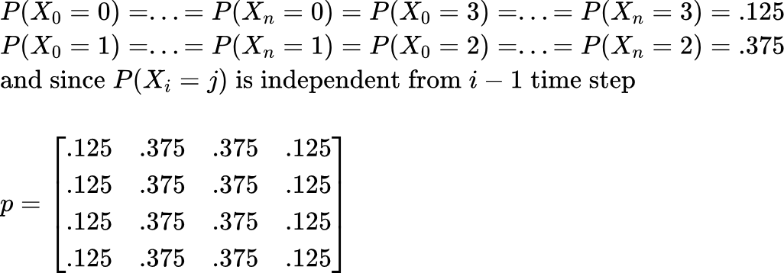



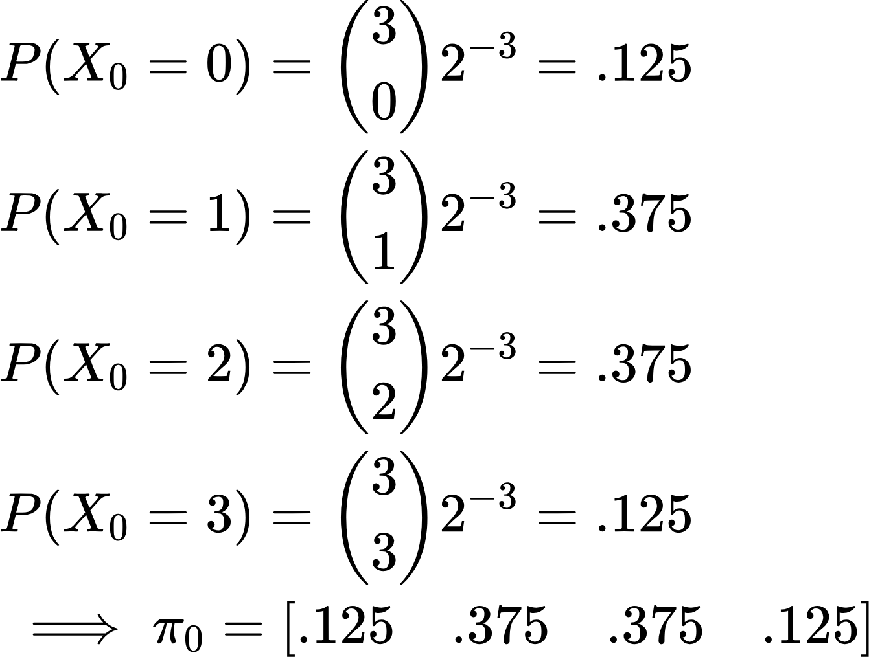



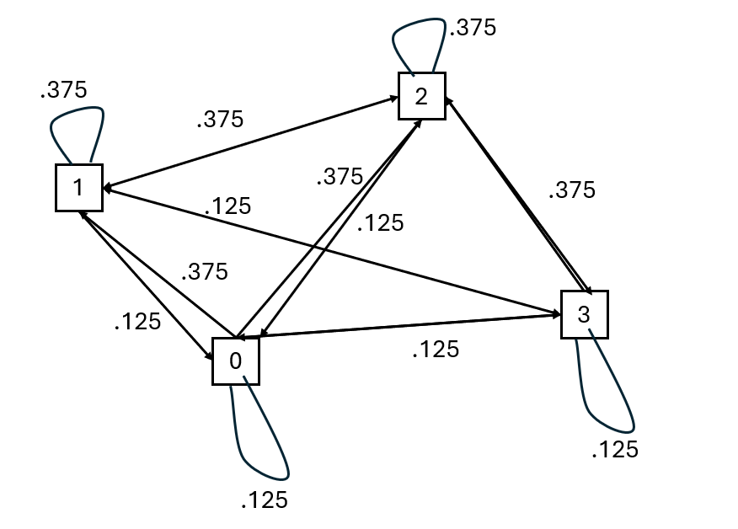



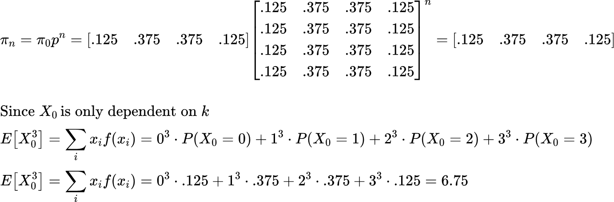

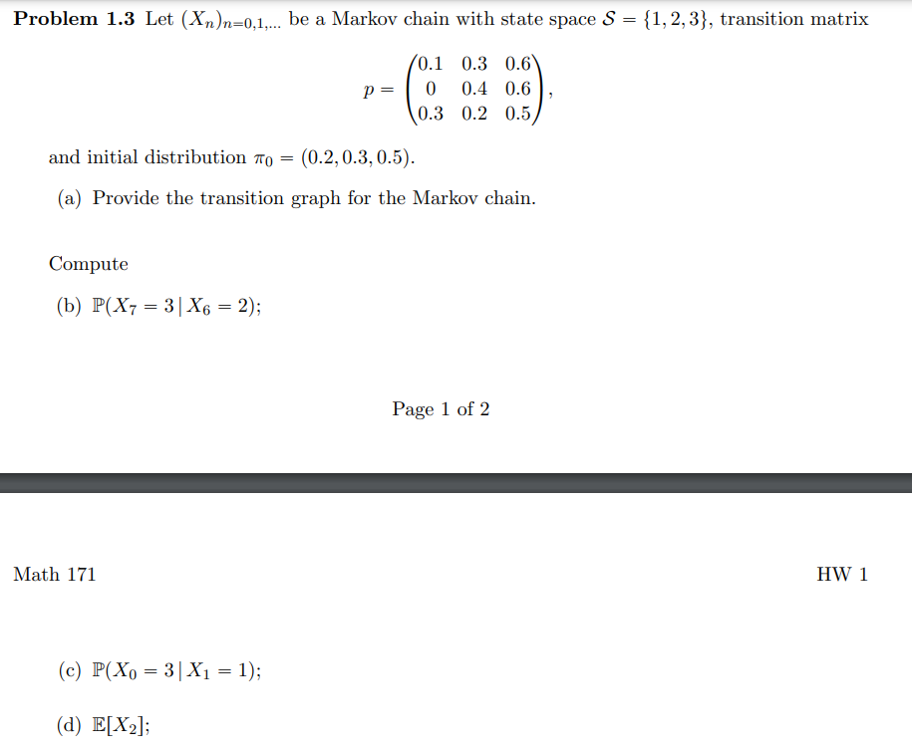

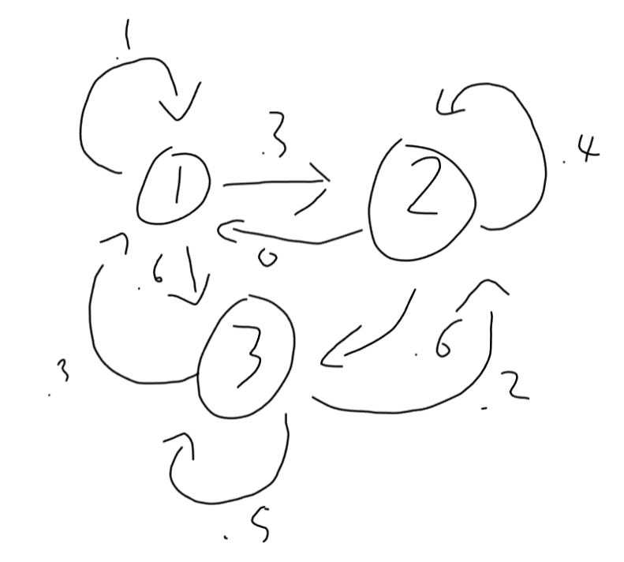



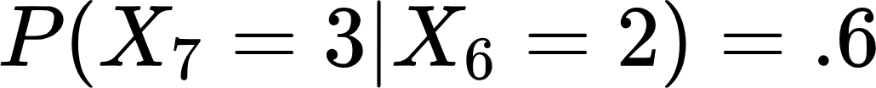







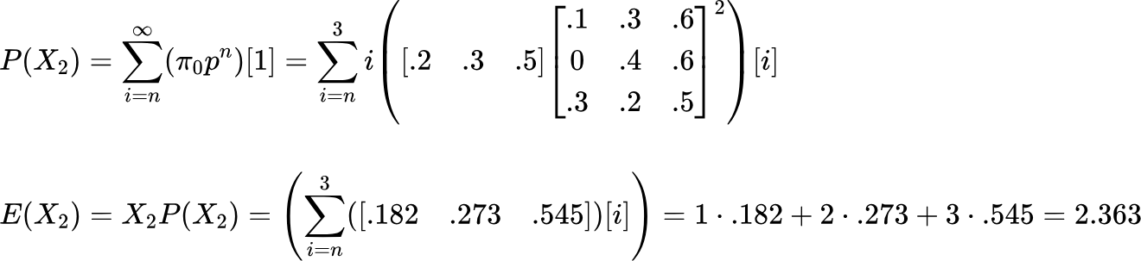

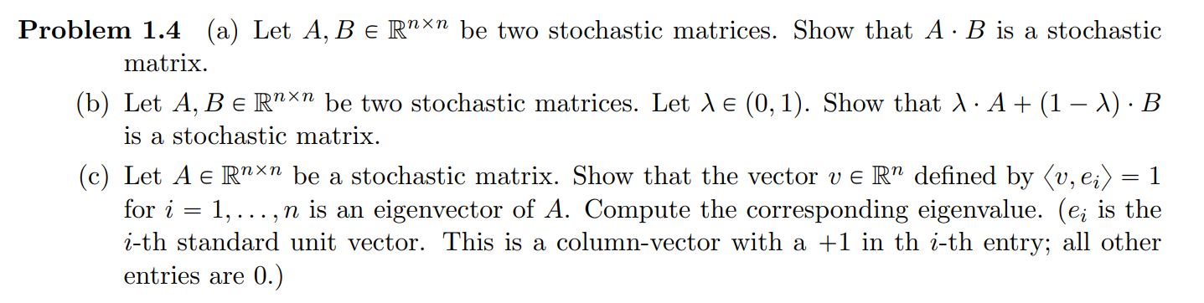

{"type":"lalign*","id":"4","backgroundColor":"#ffffff","font":{"size":11,"family":"Arial","color":"#000000"},"code":"\\begin{lalign*}\n&{\\text{let}\\;M\\in \\mathbb{R}^{n\\,x\\,n}}\\\\\n&{\\text{s.t.}\\;M=\\begin{bmatrix}\n{m_{11}}&{\\dots}&{m_{n1}}\\\\\n{\\vdots}&{\\ddots}&{\\vdots}\\\\\n{m_{1n}}&{\\dots}&{m_{nn}}\\\\\n\\end{bmatrix}}\\\\\n&{}\\\\\n&{M\\;\\text{is}\\;\\text{a}\\;\\text{stoch}\\;\\text{matrix}\\iff \\sum_{i=1}^{n}m_{ji}=1,\\forall j\\in\\left\\{1,...,n\\right\\}\\;\\text{and}\\;m_{ij}\\geq0,\\,\\forall i,j\\in\\left\\{1,...,n\\right\\}}\\\\\n&{}\\\\\n&{\\text{let}\\;A,B\\,\\;\\text{be}\\;\\text{stoch}\\;\\text{matricies}\\;}\\\\\n&{A\\cdot B=\\begin{bmatrix}\n{a_{11}}&{\\dots}&{a_{n1}}\\\\\n{\\vdots}&{\\ddots}&{\\vdots}\\\\\n{a_{1n}}&{\\dots}&{a_{nn}}\\\\\n\\end{bmatrix}\\cdot\\begin{bmatrix}\n{b_{11}}&{\\dots}&{b_{n1}}\\\\\n{\\vdots}&{\\ddots}&{\\vdots}\\\\\n{b_{1n}}&{\\dots}&{b_{nn}}\\\\\n\\end{bmatrix}=\\begin{bmatrix}\n{\\sum_{i=1}^{n}a_{i,1}\\cdot b_{1,i}}&{\\dots}&{\\sum_{i=1}^{n}a_{i,1}\\cdot b_{n,i}}\\\\\n{\\vdots}&{\\ddots}&{\\vdots}\\\\\n{\\sum_{i=1}^{n}a_{i,n}\\cdot b_{1,i}}&{\\dots}&{\\sum_{i=1}^{n}a_{i,n}\\cdot b_{n,i}}\\\\\n\\end{bmatrix}}\\\\\n&{}\\\\\n&{\\text{WTS:}\\;\\forall l\\in P\\left\\{0,...,n\\right\\},\\,\\sum_{k=1}^{n}\\left(\\sum_{i=1}^{n}a_{i,l}\\cdot b_{k,i}\\right)=1}\\\\\n&{}\\\\\n&{\\text{let}\\;l\\in P\\left\\{0,...,n\\right\\}}\\\\\n&{\\sum_{k=1}^{n}\\left(\\sum_{i=1}^{n}a_{i,l}\\cdot b_{k,i}\\right)=\\sum_{k=1}^{n}\\sum_{i=1}^{n}\\left(a_{i,l}\\cdot b_{k,i}\\right)=\\sum_{i=1}^{n}\\left(a_{i,l}\\cdot \\sum_{k=1}^{n}b_{k,i}\\right)}\\\\\n&{\\text{Since}\\;A,B\\;\\text{are}\\;\\text{stoch}\\;\\text{matrices}\\;\\implies \\sum_{i=1}^{n}m_{ji}=1,\\forall j\\in\\left\\{1,...,n\\right\\}\\;\\text{for}\\;m_{ij}\\in\\left\\{a_{ij},b_{ij}\\right\\}}\\\\\n&{\\implies\\sum_{i=1}^{n}\\left(a_{i,l}\\cdot \\sum_{k=1}^{n}b_{k,i}\\right)=\\sum_{i=1}^{n}\\left(a_{i,l}\\cdot 1\\right)=\\sum_{i=1}^{n}\\left(a_{i,l}\\right)=1}\\\\\n&{}\t\n\\end{lalign*}","aid":null,"ts":1712624221779,"cs":"IKhv3EfWqmFUusX0iNMNvg==","size":{"width":633,"height":600}}



{"type":"lalign*","code":"\\begin{lalign*}\n&{\\text{let}\\;A,B\\in\\mathbb{R}^{n\\,x\\,n\\,}\\;\\text{be}\\;\\text{stoch}\\;\\text{matrices},\\,\\lambda \\in\\left(0,1\\right)}\\\\\n&{}\\\\\n&{\\text{let}\\;A=\\begin{bmatrix}\n{a_{11}}&{\\dots}&{a_{n1}}\\\\\n{\\vdots}&{\\ddots}&{\\vdots}\\\\\n{a_{1n}}&{\\dots}&{a_{nn}}\\\\\n\\end{bmatrix},\\,B=\\begin{bmatrix}\n{b_{11}}&{\\dots}&{b_{n1}}\\\\\n{\\vdots}&{\\ddots}&{\\vdots}\\\\\n{b_{1n}}&{\\dots}&{b_{nn}}\\\\\n\\end{bmatrix}}\\\\\n&{}\\\\\n&{\\lambda\\cdot A+\\left(1-\\lambda\\right)\\cdot B=\\lambda\\begin{bmatrix}\n{a_{11}}&{\\dots}&{a_{n1}}\\\\\n{\\vdots}&{\\ddots}&{\\vdots}\\\\\n{a_{1n}}&{\\dots}&{a_{nn}}\\\\\n\\end{bmatrix}+\\left(1-\\lambda\\right)\\begin{bmatrix}\n{b_{11}}&{\\dots}&{b_{n1}}\\\\\n{\\vdots}&{\\ddots}&{\\vdots}\\\\\n{b_{1n}}&{\\dots}&{b_{nn}}\\\\\n\\end{bmatrix}}\\\\\n&{\\lambda\\cdot A+\\left(1-\\lambda\\right)\\cdot B=\\begin{bmatrix}\n{\\lambda a_{11}+\\left(1-\\lambda\\right)b_{11}}&{\\dots}&{\\lambda a_{n1}+\\left(1-\\lambda\\right)b_{n1}}\\\\\n{\\vdots}&{\\ddots}&{\\vdots}\\\\\n{\\lambda a_{1n}+\\left(1-\\lambda\\right)b_{1n}}&{\\dots}&{\\lambda a_{nn}+\\left(1-\\lambda\\right)b_{nn}}\\\\\n\\end{bmatrix}}\\\\\n&{}\\\\\n&{\\lambda\\cdot A+\\left(1-\\lambda\\right)\\cdot B\\;\\text{is}\\;\\text{a}\\;\\text{stoch}\\;\\text{matrix}\\iff\\text{all}\\;\\text{row}\\;\\text{sums}\\;\\text{equal}\\;\\text{1}}\\\\\n&{\\text{WTS:}\\;\\sum_{i=1}^{n}\\left(\\lambda a_{i,1}+\\left(1-\\lambda\\right)b_{i,1}\\right)=1}\\\\\n&{\\sum_{i=1}^{n}\\left(\\lambda a_{i,1}+\\left(1-\\lambda\\right)b_{i,1}\\right)=\\lambda\\sum_{i=1}^{n}a_{i,1}+\\left(1-\\lambda\\right)\\sum_{i=1}^{n}b_{i,1}}\\\\\n&{\\text{Since}\\text{,}\\;A,B\\;\\text{are}\\;\\text{stoch}\\;\\text{matrices}\\implies\\sum_{i=1}^{n}a_{i,1}=\\sum_{i=1}^{n}b_{i,1}=1}\\\\\n&{\\lambda\\sum_{i=1}^{n}a_{i,1}+\\left(1-\\lambda\\right)\\sum_{i=1}^{n}b_{i,1}=\\lambda\\left(1\\right)+\\left(1-\\lambda\\right)\\left(1\\right)=1}\t\n\\end{lalign*}","font":{"family":"Arial","size":11,"color":"#000000"},"id":"5","aid":null,"backgroundColor":"#ffffff","ts":1712626295352,"cs":"Pf7pad4dRH8KdntQKkSSmA==","size":{"width":492,"height":568}}



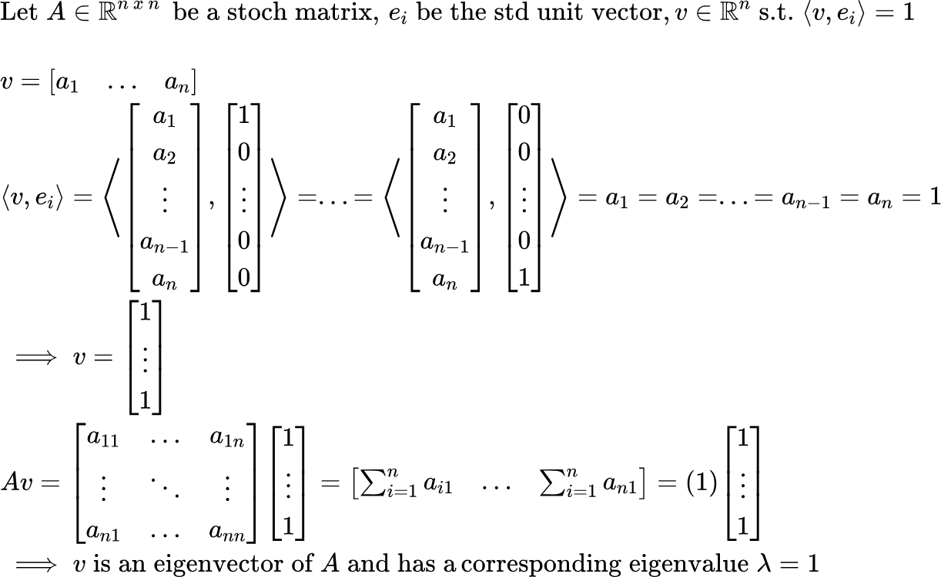

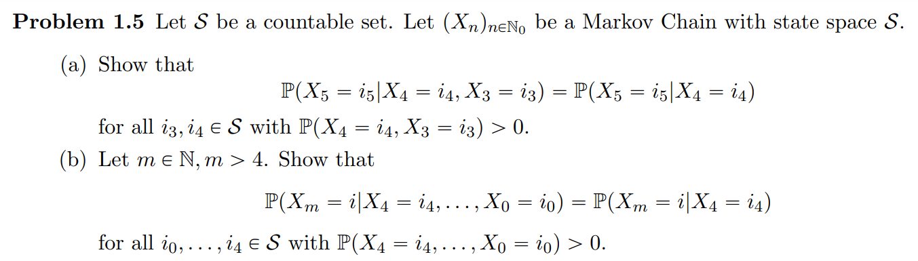

{"aid":null,"type":"lalign*","font":{"color":"#000000","family":"Arial","size":8},"backgroundColor":"#ffffff","code":"\\begin{lalign*}\n&{\\text{let}\\;S\\;\\text{be}\\;\\text{a}\\;\\text{countable}\\;\\text{set},\\;\\left(X_{n}\\right)_{n\\in\\mathbb{N}}\\;\\text{be}\\;\\text{a}\\;\\text{seq}\\;\\text{of}\\;S\\text{-random}\\;\\text{variables}}\\\\\n&{\\text{WTS:}\\;\\;P\\left(X_{5}=i_{5}\\text{|}X_{4}=i_{4},X_{3}=i_{3}\\right)=P\\left(X_{5}=i_{5}\\text{|}X_{4}=i_{4}\\right)}\\\\\n&{}\\\\\n&{P\\left(X_{5}=i_{5}\\text{|}X_{4}=i_{4},X_{3}=i_{3}\\right)=\\frac{P\\left(X_{5}=i_{5},X_{4}=i_{4},X_{3}=i_{3}\\right)}{P\\left(X_{4}=i_{4},X_{3}=i_{3}\\right)}=\\frac{\\sum_{i_{0},i_{1},i_{2}}^{}P\\left(X_{5}=i_{5},X_{4}=i_{4},X_{3}=i_{3},...,X_{0}=i_{0}\\right)}{\\sum_{i_{0},i_{1},i_{2}}^{}P\\left(X_{4}=i_{4},X_{3}=i_{3},...,X_{0}=i_{0}\\right)}}\\\\\n&{P\\left(X_{5}=i_{5}\\text{|}X_{4}=i_{4},X_{3}=i_{3},...,X_{0}=i_{0}\\right)=\\frac{P\\left(X_{5}=i_{5},X_{4}=i_{4},X_{3}=i_{3},...,X_{0}=i_{0}\\right)}{P\\left(X_{4}=i_{4},X_{3}=i_{3},...,X_{0}=i_{0}\\right)}}\\\\\n&{\\implies P\\left(X_{5}=i_{5},X_{4}=i_{4},,...,X_{0}=i_{0}\\right)=P\\left(X_{5}=i_{5}\\text{|}X_{4}=i_{4},...,X_{0}=i_{0}\\right)\\cdot P\\left(X_{4}=i_{4},...,X_{0}=i_{0}\\right)}\\\\\n&{}\\\\\n&{\\frac{\\sum_{i_{0},i_{1},i_{2}}^{}P\\left(X_{5}=i_{5},X_{4}=i_{4},X_{3}=i_{3},...,X_{0}=i_{0}\\right)}{\\sum_{i_{0},i_{1},i_{2}}^{}P\\left(X_{4}=i_{4},X_{3}=i_{3},...,X_{0}=i_{0}\\right)}=\\frac{\\sum_{i_{0},i_{1},i_{2}}^{}P\\left(X_{5}=i_{5}\\text{|}X_{4}=i_{4},...,X_{0}=i_{0}\\right)\\cdot P\\left(X_{4}=i_{4},...,X_{0}=i_{0}\\right)}{\\sum_{i_{0},i_{1},i_{2}}^{}P\\left(X_{4}=i_{4},X_{3}=i_{3},...,X_{0}=i_{0}\\right)}}\\\\\n&{}\\\\\n&{\\text{Since}\\;X_{5}\\;\\text{is}\\;\\text{indepedent}\\;\\text{of}\\;X_{2},...,X_{0}\\implies P\\left(X_{5}=i_{5}\\text{|}X_{4}=i_{4},...,X_{0}=i_{0}\\right)=P\\left(X_{5}=i_{5}\\text{|}X_{4}=i_{4}\\right)\\,\\;\\text{and}\\;\\text{by}\\;\\text{MK}\\;\\text{chain}\\;\\text{prop}}\\\\\n&{\\frac{P\\left(X_{5}=i_{5}\\text{|}X_{4}=i_{4},...,X_{0}=i_{0}\\right)\\cdot\\sum_{i_{0},i_{1},i_{2}}^{}P\\left(X_{4}=i_{4},...,X_{0}=i_{0}\\right)}{\\sum_{i_{0},i_{1},i_{2}}^{}P\\left(X_{4}=i_{4},X_{3}=i_{3},...,X_{0}=i_{0}\\right)}=\\frac{P\\left(X_{5}=i_{5}\\text{|}X_{4}=i_{4}\\right)\\cdot\\sum_{i_{0},i_{1},i_{2}}^{}P\\left(X_{4}=i_{4},...,X_{0}=i_{0}\\right)}{\\sum_{i_{0},i_{1},i_{2}}^{}P\\left(X_{4}=i_{4},X_{3}=i_{3},...,X_{0}=i_{0}\\right)}}\\\\\n&{\\implies P\\left(X_{5}=i_{5}\\text{|}X_{4}=i_{4},X_{3}=i_{3}\\right)=P\\left(X_{5}=i_{5}\\text{|}X_{4}=i_{4}\\right)}\t\n\\end{lalign*}","id":"11-0","ts":1713038292795,"cs":"yCyKZ/5TMQUFSH3ZLzZ+/g==","size":{"width":665,"height":276}}



{"id":"18","font":{"family":"Arial","size":9,"color":"#000000"},"backgroundColorModified":false,"code":"\\begin{lalign*}\n&{\\text{When}\\;m=5}\\\\\n&{\\text{WTS:}\\;P\\left(X_{5}=i_{5}\\text{|}X_{4}=i_{4},...,X_{0}=i_{0}\\right)=P\\left(X_{5}=i_{5}\\text{|}X_{4}=i_{4}\\right)}\\\\\n&{\\text{By}\\;\\text{MK}\\;\\text{prop:}\\;P\\left(X_{5}=i_{5}\\text{|}X_{4}=i_{4},...,X_{0}=i_{0}\\right)=P\\left(X_{5}=i_{5}\\text{|}X_{4}=i_{4}\\right)}\\\\\n&{}\\\\\n&{\\text{IH:}\\;P\\left(X_{m}=i_{m}\\text{|}X_{m-1}=i_{m-1},...,X_{0}=i_{0}\\right)=P\\left(X_{m}=i_{m}\\text{|}X_{4}=i_{4}\\right)}\\\\\n&{}\\\\\n&{\\text{WTS:}\\;P\\left(X_{m+1}=i_{m+1}\\text{|}X_{4}=i_{m},...,X_{0}=i_{0}\\right)=P\\left(X_{m}=i_{m}\\text{|}X_{4}=i_{4}\\right)}\\\\\n&{}\\\\\n&{P\\left(X_{m+1}=i_{m+1}\\text{|}X_{4}=i_{4},...,X_{0}=i_{0}\\right)=\\frac{P\\left(X_{m+1}=i_{m+1},X_{4}=i_{4},...,X_{0}=i_{0}\\right)}{P\\left(X_{4}=i_{4},...,X_{0}=i_{0}\\right)}}\\\\\n&{P\\left(X_{m+1}=i_{m+1}\\text{|}X_{4}=i_{4},...,X_{0}=i_{0}\\right)=\\frac{\\sum_{i_{5},...,i_{m}}^{}P\\left(X_{m+1}=i_{m+1},X_{m}=i_{m},...,X_{0}=i_{0}\\right)}{P\\left(X_{4}=i_{4},...,X_{0}=i_{0}\\right)}}\\\\\n&{=\\frac{\\sum_{i_{5},...,i_{m}}^{}P\\left(X_{m+1}=i_{m+1}\\text{|}X_{m}=i_{m},...,X_{0}=i_{0}\\right)\\cdot P\\left(X_{m}=i_{m},...,X_{0}=i_{0}\\right)}{P\\left(X_{4}=i_{4},...,X_{0}=i_{0}\\right)}}\\\\\n&{=\\frac{\\sum_{i_{5},...,i_{m}}^{}P\\left(X_{m+1}=i_{m+1}\\text{|}X_{m}=i_{m},...,X_{0}=i_{0}\\right)\\cdot P\\left(X_{m}=i_{m}\\text{|}X_{4}=i_{4}...,X_{0}=i_{0}\\right)\\cdot P\\left(X_{4}=i_{4},...,X_{0}=i_{0}\\right)}{P\\left(X_{4}=i_{4},...,X_{0}=i_{0}\\right)}}\\\\\n&{=\\sum_{i_{5},...,i_{m}}^{}P\\left(X_{m+1}=i_{m+1}\\text{|}X_{m}=i_{m},...,X_{0}=i_{0}\\right)\\cdot P\\left(X_{m}=i_{m}\\text{|}X_{4}=i_{4}...,X_{0}=i_{0}\\right)}\\\\\n&{=\\sum_{i_{5},...,i_{m}}^{}P\\left(X_{m+1}=i_{m+1}\\text{|}X_{m}=i_{m}\\right)\\cdot P\\left(X_{m}=i_{m}\\text{|}X_{4}=i_{4}\\right)}\\\\\n&{=\\sum_{i_{5},...,i_{m}}^{}\\frac{P\\left(X_{m+1}=i_{m+1},X_{m}=i_{m}\\right)}{P\\left(X_{m}=i_{m}\\right)}\\cdot \\frac{P\\left(X_{m}=i_{m},X_{4}=i_{4}\\right)}{P\\left(X_{4}=i_{4}\\right)}}\\\\\n&{=\\sum_{i_{5},...,i_{m}}^{}\\frac{P\\left(X_{m+1}=i_{m+1},X_{m}=i_{m}\\right)}{P\\left(X_{4}=i_{4}\\right)}\\cdot \\frac{P\\left(X_{m}=i_{m},X_{4}=i_{4}\\right)}{P\\left(X_{m+1}=i_{m+1},X_{m}=i_{m}\\right)}\\cdot \\frac{P\\left(X_{m+1}=i_{m+1},X_{m}=i_{m}\\right)}{P\\left(X_{m}=i_{m}\\right)}}\\\\\n&{=\\sum_{i_{5},...,i_{m}}^{}\\frac{P\\left(X_{m+1}=i_{m+1},X_{m}=i_{m}\\right)}{P\\left(X_{4}=i_{4}\\right)}\\cdot \\frac{P\\left(X_{m+1}=i_{m+1}\\text{|}X_{m}=i_{m}\\right)}{P\\left(X_{m+1}=i_{m+1}\\text{|}X_{m}=i_{m},X_{4}=i_{4}\\right)}=\\sum_{i_{5},...,i_{m}}^{}\\frac{P\\left(X_{m+1}=i_{m+1},X_{m}=i_{m}\\right)}{P\\left(X_{4}=i_{4}\\right)}}\\\\\n&{=\\frac{P\\left(X_{m+1}=i_{m+1},X_{m}=i_{m}\\right)}{P\\left(X_{4}=i_{4}\\right)}=P\\left(X_{m+1}=i_{m+1},X_{m}=i_{m}\\text{|}X_{4}=i_{4}\\right)}\\\\\n\\end{lalign*}","aid":null,"type":"lalign*","backgroundColor":"#ffffff","ts":1713042075071,"cs":"8VqdTyqn3Rz18Xj3sNWG/A==","size":{"width":669,"height":550}}

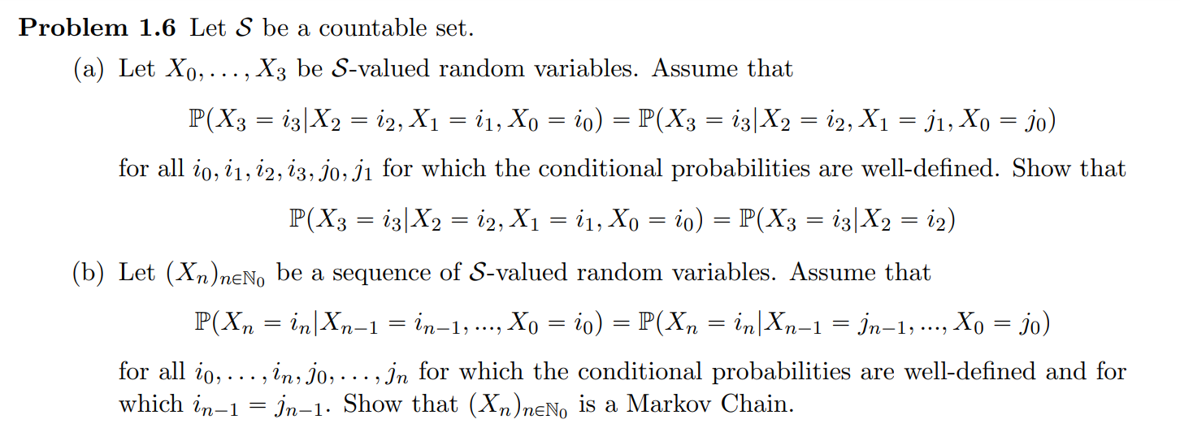

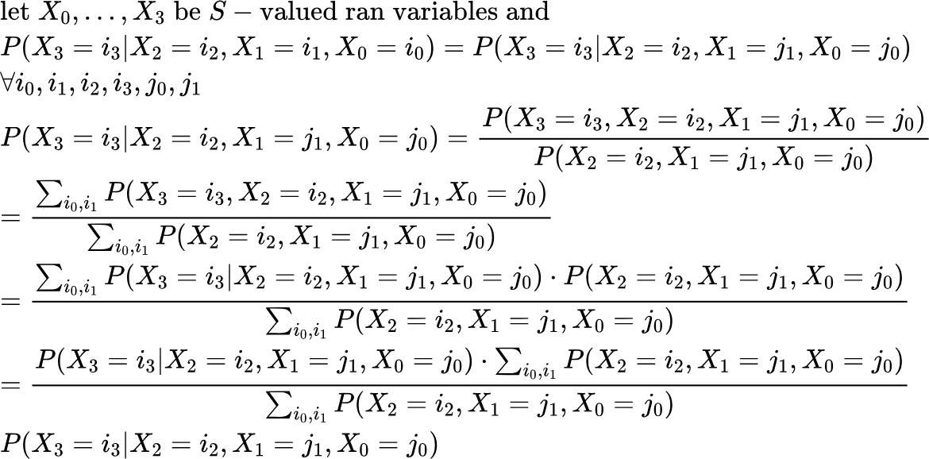



{"aid":null,"font":{"size":11,"color":"#000000","family":"Arial"},"id":"12","code":"\\begin{lalign*}\n&{\\text{let}\\;\\left(X_{n}\\right)_{n\\in\\mathbb{N_{0}}}\\text{be}\\;\\text{a}\\;\\text{sequence}\\;\\text{of}\\;S\\text{-}\\text{valued}\\;\\text{ran}\\;\\text{variables}\\;\\text{and}\\;}\\\\\n&{P\\left(X_{n}=i_{n}\\text{|}X_{n-1}=i_{n-1},...,X_{0}=i_{0}\\right)=P\\left(X_{n}=i_{n}\\text{|}X_{n-1}=j_{n-1},...,X_{0}=j_{0}\\right)}\\\\\n&{\\forall i_{0},i_{1},i_{2},i_{3},j_{0},j_{1}}\\\\\n&{}\\\\\n&{\\text{BC:}\\;i=1}\\\\\n&{P\\left(X_{1}=i_{1}\\text{|}X_{0}=i_{0}\\right)=P\\left(X_{1}=j_{1}\\text{|}X_{0}=j_{0}\\right)}\\\\\n&{\\text{which}\\;\\text{is}\\;\\text{true}\\;\\text{since}\\;\\text{there}\\;\\text{are}\\;\\text{only}\\;\\text{two}\\;\\text{variables}\\;\\text{and}\\;\\text{thus}\\;P\\left(X_{1}=i_{1}\\text{|}X_{0}=i_{0}\\right)\\;}\\\\\n&{\\text{is}\\;\\text{dependent}\\;\\text{on}\\;\\text{itself}\\;}\\\\\n&{}\\\\\n&{\\text{IH}\\text{:}\\;\\left(X_{n}\\right)_{n\\in\\mathbb{N_{0}}}\\;\\text{is}\\;\\text{a}\\;\\text{markov}\\;\\text{chain}\\;}\\\\\n&{\\text{WTS:}\\;\\left(X_{n+1}\\right)_{n\\in\\mathbb{N_{0}}}\\;\\text{is}\\;\\text{a}\\;\\text{markov}\\;\\text{chain}\\;}\\\\\n&{}\\\\\n&{\\left(X_{n}\\right)_{n\\in\\mathbb{N_{0}}}\\implies P\\left(X_{n}=i_{n}\\text{|}X_{n-1}=i_{n-1}\\right)=P\\left(X_{n}=i_{n}\\text{|}X_{n-1}=i_{n-1},...,X_{0}=i_{0}\\right)}\\\\\n&{}\\\\\n&{P\\left(X_{n+1}=i_{n+1}\\text{|}X_{n}=i_{n},...,X_{0}=i_{0}\\right)=\\frac{P\\left(X_{n+1}=i_{n+1},X_{n}=i_{n},...,X_{0}=i_{0}\\right)}{P\\left(X_{n}=i_{n},...,X_{0}=i_{0}\\right)}}\\\\\n&{=\\frac{\\sum_{i_{0},...,i_{n}}^{}P\\left(X_{n+1}=i_{n+1},X_{n}=i_{n},...,X_{0}=i_{0}\\right)}{\\sum_{i_{0},...,i_{n}}^{}P\\left(X_{n}=i_{n},...,X_{0}=i_{0}\\right)}}\\\\\n&{=\\frac{\\sum_{i_{0},...,i_{n}}^{}P\\left(X_{n+1}=i_{n+1}\\text{|}X_{n}=i_{n},...,X_{0}=i_{0}\\right)\\cdot P\\left(X_{n}=i_{n},...,X_{0}=i_{0}\\right)}{\\sum_{i_{0},...,i_{n}}^{}P\\left(X_{n}=i_{n},...,X_{0}=i_{0}\\right)}}\\\\\n&{=\\frac{P\\left(X_{n+1}=i_{n+1}\\text{|}X_{n}=i_{n}\\right)\\sum_{i_{0},...,i_{n}}^{}\\cdot P\\left(X_{n}=i_{n},...,X_{0}=i_{0}\\right)}{\\sum_{i_{0},...,i_{n}}^{}P\\left(X_{n}=i_{n},...,X_{0}=i_{0}\\right)}=P\\left(X_{n+1}=i_{n+1}\\text{|}X_{n}=i_{n}\\right)}\t\n\\end{lalign*}","backgroundColor":"#ffffff","type":"lalign*","ts":1713048860239,"cs":"vHMYkDhUdnRSto/szdp2Dw==","size":{"width":656,"height":530}}

